**Newton’s Ring**

**Experiment No:** __________ **Date:** ________________

**Aim:**

To determine the wavelength of sodium light by Newton’s ring method

**Apparatus:**

1. Sodium vapour lamp with transformer
2. Spherometer
3. Magnifying glass
4. Newton’s ring apparatus fitted with travelling microscope

**Description:**

It consists of an optically plane glass plate ‘G’ and a Plano-convex lens ‘L’ of large radius of curvature. The curved surface of L is in contact with G and both are enclosed in circular frame F. Air film of increased thickness is formed. Thickness is zero at the point of contact and goes on increasing towards periphery of the lens. The thickness of the film along a circle with the point of contact as the centre is same. There is another optically plane glass plate P, the angle of inclination of which can be changed and is kept 450 with the horizontal. In an optical arrangement of Newton’s ring, light from a monochromatic source (Sodium vapour lamp) is allowed to fall on a convex lens through a broad slit which renders into a nearly parallel beam. These beams fall on plate P and reflect from lower surface of P. The reflected parallel beam is made incident on the air film vertically. A part of the incident ray is reflected from the top surface of the film (Glass-air boundary) and goes as ray 1 without phase reversal. The other part is refracted along the air film and incident at the plane glass plate G and gets reflected and goes out as ray 2 with phase reversal of $π.$ Ray 1 and 2 satisfy the condition of interference and produce concentric circular fringes which are observed through travelling microscope.

**Theory:**

The central ring is dark. This is because of the fact that when light is reflected at a denser medium, a phase change of $π$ or a path change of $\frac{λ}{2}$ is introduced. If ‘R’ is the radius of curvature of the curved surface of the lens and $λ$ is the wavelength of the light used, then the diameter of the nth dark ring is given by

$D_{n}^{2}=4nλR$......................................... (1)

Similarly the diameter of (n+m)th dark ring is given by

$D_{n+m}^{2}=4(n+m)λR$......................... (2)

From (1) and (2) the wavelength of light is given by

$$λ=\frac{D_{n+m}^{2}-D_{n}^{2}}{4mR}$$

Where $λ$ = wave length of light

$D_{n+m}$ = Diameter of ${(n+m)}^{th}$ dark ring

$D_{n}$ = Diameter of *nth* dark ring

$m$ = Number of ring

$R$ = Radius of the curved surface of the lens in contact with glass plate

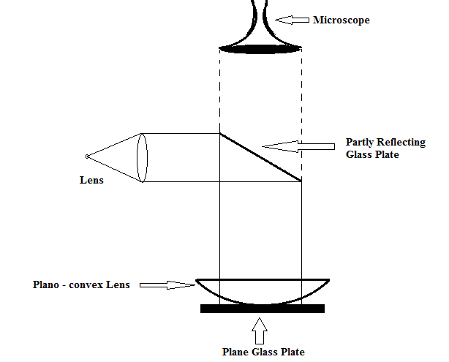

**Procedure:**

1. Clean the surfaces of glass plate G and the lens L with a neat and clean handke3rchief.please both of them in the circular frame, so that curved surface of the lens is in contact with the plate.
2. Clean the glass plate P and set the plate P, so that it is inclined at an angle 45 with the direction of incidence rays.
3. Place the whole arrangement near a sodium lamp and adjust the slit of the lamp so that the slit and the centre of plate Pare at the same height.
4. Insert a convex lens in between slit and the plate P so that slit is at the focus of the lens and parallel rays are incident on the plate and see that the rays after reflection from P fall normally on the lens L surface.
5. Find Vernier constant of travelling microscope. If need be level the microscope. Set the microscope tube in vertical position and adjust the position of microscope so that point of contact of lens and plate G is just below the centre of the objective of the microscope.
6. Focus the microscope; so that alternate dark and bright rings are clearly visible. Slightly move the lens to bring the centre of the fringes to come in view [Newton’s ring would be visible at the centre of the lens even to the naked eye].
7. Adjust the position of microscope, till the point of intersection of the cross wires lied at the centre of the ring system and one of the cross wire is at right angle to the horizontal scale.
8. With the help slow motion screw, slide the microscope on one of the sides, say left, till the crosswire lies tangentially at the centre of a certain dark ring[say,20th].Note the reading of the microscope on the horizontal scale.
9. Slide the microscope backward with the slow motion screw and take readings, when the crosswire lies tangentially at the centre of 20th, 18th, 16th, 14th..........dark rings and go up to 2nd ring. Note the readings of the microscope at each stage.
10. Keep on sliding the microscope in the same direction till cross wire lies tangentially at the centre of the 2nd dark rings on the right slide. Note the microscope reading. Continue moving the microscope and take reading at the centres of 2nd, 4th, 6th, 8th...... and go up to 20thdark ring.
11. Record your observations in the tabular form. The difference between reading of microscope for a particular order form left hand A and right hand B gives the diameter of the 20th ring. Similarly calculate the diameters D of all the rings up to 2nd ring. Knowing the diameters calculate their squares D2 (Table 1).
12. Plot a graph between no. Of rings (in X-axis) and D2 (in Y-axis).
13. The slope of the graph results.

**Measurement of 'R’ by Spherometer**

1. The radius of curvature of Plano-convex lens can be measured by using spherometer using the formula $R=\frac{l^{2}}{6h}+\frac{h}{2}$. Here ‘*l*’ is the distance between two consecutive legs of spherometer and ‘h’ is the height (or length) from the plane surface to which the central leg of the spherometer moves to touch the convex lens.

**Precautions:**

1. The lens and the glass plates should be thoroughly cleaned. The lens should have large radius of curvature.
2. The glass plate should be inclined at an angle of 450 so that light is incident normally on the Plano-convex lens.
3. The point of intersection of cross-wires should lie at the centre of bright rings.
4. The microscope should always be moved in the same direction to avoid error due to backlash.
5. The radius of curvature and diameters of the rings should be measured accurately.

**Observations:**

Vernier constant of microscope =............................. cm

**Table – 1:** (Tabulation for diameters of rings)

|  |  |  |  |  |  |  |  |  |  |  |
| --- | --- | --- | --- | --- | --- | --- | --- | --- | --- | --- |
| Sl. No. Of the rings | Micrometer Reading | | | | | | | | Diameter **D = A – B** in cm. | **D2 = (A – B)2** in cm2 |
| Left end ‘A’ in cm. | | | | Right end ‘B’ in cm. | | | |
| MSR in cm | VR | VSR in cm | Total in cm | MSR in cm | VR | VSR in cm | Total in cm |
| 20 |  |  |  |  |  |  |  |  |  |  |
| 18 |  |  |  |  |  |  |  |  |  |  |
| 16 |  |  |  |  |  |  |  |  |  |  |
| 14 |  |  |  |  |  |  |  |  |  |  |
| 12 |  |  |  |  |  |  |  |  |  |  |
| 10 |  |  |  |  |  |  |  |  |  |  |
| 08 |  |  |  |  |  |  |  |  |  |  |
| 06 |  |  |  |  |  |  |  |  |  |  |
| 04 |  |  |  |  |  |  |  |  |  |  |
| 02 |  |  |  |  |  |  |  |  |  |  |

**Table – 2:** (Tabulation for ‘R’)

|  |  |  |  |  |  |  |  |  |  |  |
| --- | --- | --- | --- | --- | --- | --- | --- | --- | --- | --- |
| No of obs. | ICSR | FCSR | Diff. | NCR | PSR in cm | CSR in cm | Total in cm | Mean *‘h’* in cm | $l=3$ cm | $R=\frac{l^{2}}{6h}+\frac{h}{2}$ in cm |
| 1 |  |  |  |  |  |  |  |  |  |  |
| 2 |  |  |  |  |  |  |  |  |  |  |
| 3 |  |  |  |  |  |  |  |  |  |  |

**Graph:**

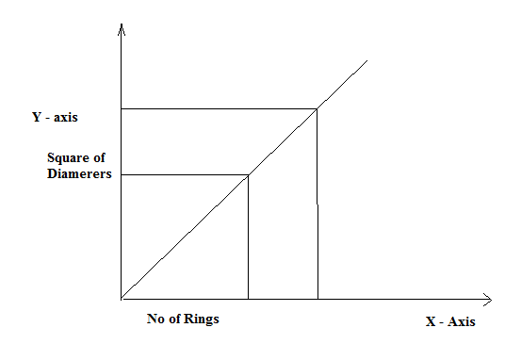

**Calculation:**

Substituting the value of slope, i.e. $\frac{D_{n+m}^{2}-D_{n}^{2}}{m}$ and ‘*R’* in the working formula

$λ=\frac{D_{n+m}^{2}-D_{n}^{2}}{m}×\frac{1}{4R}$

=

**Standard Value:**

Wavelength of sodium light is $λ=5893 A^{0}$

**Percentage of Error:**

% of Error $=\frac{\left|Standard Value-Measured Value\right|}{Standard Value}×100$

**=**

**Conclusion:**

With the use of Newton’s ring apparatus, the wavelength of sodium light (Monochromatic) was found to be ......................... with.............................% of error.

**Marks Awarded**

Signature of the student:

|  |  |  |  |
| --- | --- | --- | --- |
| Planning and Execution  (2) | Result and Report  (6) | Viva  (2) | Total  (10) |
|  |  |  |  |

Regd No:

Group:

Branch:

Signature of the faculty